Chapter 4
Introduction to unsupervised learning and dimensionality reduction
Introduction to clustering
K-Mean clustering
Different distance function of clustering
Hierarchical clustering
Supervised learning after clustering
Dimensionality Reduction techniques
Principal component analysis

What is unsupervised learning?
Unsupervised learning is also a very common type of machine learning. It differs from supervised learning in that the data has no labels. What is a dataset with no labels, you ask? Well, it is a dataset with only features, and no target to predict. For example, if our housing dataset had no prices, then it would be an unlabeled dataset. If our emails dataset had no labels, then it would simply be a dataset of emails, where ‘spam’ and ‘no spam’ is not specified.
So what could you do with such a dataset? Well, a little less than with a labelled dataset, unfortunately, since the main thing we are aiming to predict is not there. However, we can still extract a lot of information from an unlabelled dataset. Here is an example, let us go back to the cats and dogs example in Figure . If our dataset has no labels, then we simply have a bunch of pictures of dogs and cats, and we do not know what type of pet each one represents. Our model can still tell us if two pictures of dogs are similar to each other, and different to a picture of a cat. Maybe it can group them in some way by similarity, even without knowing what each group represents.
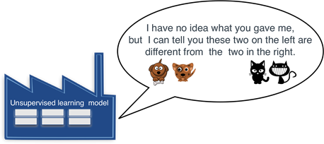
Figure : An unsupervised learning model can still extract information from data, for example, it can group similar elements together.

And the branch of machine learning that deals with unlabelled datasets is called unsupervised machine learning. As a matter of fact, even if the labels are there, we can still use unsupervised learning techniques on our data, in order to preprocess it and apply supervised learning methods much more effectively.
The two main branches of unsupervised learning are clustering and dimensionality reduction. They are defined as follows.
Clustering: This is the task of grouping our data into clusters based on similarity. (This is what we saw in Figure above )
Dimensionality reduction: This is the task of simplifying our data and describing it with fewer features, without losing much generality.
Let’s study them in more detail.
Clustering algorithms split a dataset into similar groups
As we stated previously, clustering algorithms are those that look at a dataset, and split it into similar groups
So let’s go back to our two examples. In the first one, we have a dataset with information about houses, but no prices. What could we do? Here is an idea: we could somehow group them into similar houses. We could group them by location, by price, by size, or by a combination of these factors. This is called clustering. Clustering is a branch of unsupervised machine learning which consists of grouping the elements in our dataset into clusters that are similar. Could we do that with other datasets?
Let’s look at our second example, the dataset of emails. Because the dataset is unlabeled, we don’t know if each email is spam or not. However, we can still apply some clustering to our dataset. A clustering algorithm will return our emails split into, say, 4 or 5 different categories, based on different features such as words in the message, sender, attachments, types of links on them, and more. It is then up to a human (or a supervised learning algorithm) to label categories such as ‘Personal’, ‘Social’, ‘Promotions’, and others.
For example, let’s say that we have 9 emails, and we want to cluster them into different types. We have, say, the size of the email, and the number of recipients. And the data looks like this, ordered by number of recipients:
Table : A table of emails with their size and number of recipients.
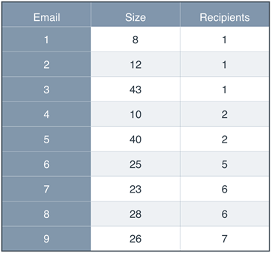
To the naked eye, it looks like we could group them by size, where the emails in one group would have 1 or 2 recipients, and the emails in the other group would have 5 or more recipients. We could also try to group them into three groups by size. But you can imagine that as the data gets larger and larger, eyeballing the groups gets harder and harder. What if we plot the data? Let’s plot the emails in a graph, where the horizontal axis records the size, and the vertical axis records the number of recipients. We get the following plot.
Figure : A plot of the emails with size on the horizontal axis and number of recipients on the vertical axis. Eyeballing it, it is obvious that there are three distinct types of emails.
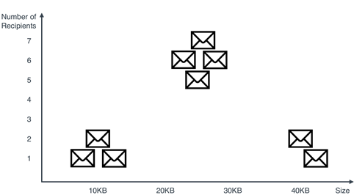
In Figure, we can see three groups, very well defined. We can make each a different category in our inbox. They are the ones we see in Figure below .
Figure : Clustering the emails into three categories based on size and number of recipients.
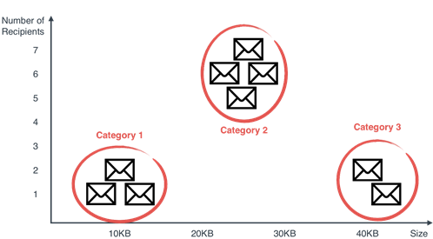
This last step is what clustering is all about. Of course, for us humans, it was very easy to eyeball the three groups once we have the plot. But for a computer, this is not easy. And furthermore, imagine if our data was formed by millions of points, with hundreds or thousands of columns. All of a sudden, we cannot eyeball the data, and clustering becomes hard. Luckily, computers can do these type of clustering for huge datasets with lots of columns.
Other applications of clustering are the following:
- Market segmentation: Dividing customers into groups based on demographic and purchasing (or engagement) behavior, in order to create different marketing strategies for the groups.
- Genetics: Clustering species into groups based on similarity.
- Medical imaging: Splitting an image into different parts in order to study different types of tissue.
UNSUPERVISED LEARNING ALGORITHMS
Here we don’t get to study unsupervised learning. Some of the most important clustering algorithms out there.
- K-means clustering: This algorithm groups points by picking some random centers of mass, and moving them closer and closer to the points until they are at the right spots.
- Hierarchical clustering: This algorithm starts by grouping the closest points together, and continuing in this fashion, until we have some well defined groups.
- Density-based special clustering (DBSCAN): This algorithm starts grouping points together in points of high density, while leaving the isolated points as noise.
- Gaussian mixture models: This algorithm doesn’t actually determine if an element belongs to a cluster, but instead gives a breakdown of percentages. For example, if there are three clusters, A, B, and C, then the algorithm could say that a point belongs 60% to group A, 25% to group B, and 15% to group C.

Introduction to clustering
Clustering or cluster analysis is a machine learning technique, which groups the unlabelled dataset. It can be defined as "A way of grouping the data points into different clusters, consisting of similar data points. The objects with the possible similarities remain in a group that has less or no similarities with another group."
It does it by finding some similar patterns in the unlabelled dataset such as shape, size, color, behavior, etc., and divides them as per the presence and absence of those similar patterns.
It is an unsupervised learning method, hence no supervision is provided to the algorithm, and it deals with the unlabeled dataset.
After applying this clustering technique, each cluster or group is provided with a cluster-ID. ML system can use this id to simplify the processing of large and complex datasets.
The clustering technique is commonly used for statistical data analysis.

, Note: Clustering is somewhere similar to the classification algorithm but the difference is the type of dataset that we are using. In classification, we work with the labeled data set, whereas in clustering, we work with the unlabelled dataset.
Example: Let's understand the clustering technique with the real-world example of Mall: When we visit any shopping mall, we can observe that the things with similar usage are grouped together. Such as the t-shirts are grouped in one section, and trousers are at other sections, similarly, at vegetable sections, apples, bananas, Mangoes, etc., are grouped in separate sections, so that we can easily find out the things. The clustering technique also works in the same way. Other examples of clustering are grouping documents according to the topic.
The clustering technique can be widely used in various tasks. Some most common uses of this technique are:
- Market Segmentation
- Statistical data analysis
- Social network analysis
- Image segmentation
- Anomaly detection, etc.
Apart from these general usages, it is used by the Amazon in its recommendation system to provide the recommendations as per the past search of products. Netflix also uses this technique to recommend the movies and web-series to its users as per the watch history.

Types of Clustering Methods
The clustering methods are broadly divided into Hard clustering (datapoint belongs to only one group) and Soft Clustering (data points can belong to another group also). But there are also other various approaches of Clustering exist. Below are the main clustering methods used in Machine learning:
- Partitioning Clustering
- Density-Based Clustering
- Distribution Model-Based Clustering
- Hierarchical Clustering
- Fuzzy Clustering

K-Means Clustering Algorithm
K-Means Clustering is an unsupervised learning algorithm that is used to solve the clustering problems in machine learning or data science. In this topic, we will learn what is K-means clustering algorithm, how the algorithm works, along with the Python implementation of k-means clustering.

What is K-Means Algorithm?
K-Means Clustering is an Unsupervised Learning algorithm, which groups the unlabeled dataset into different clusters. Here K defines the number of pre-defined clusters that need to be created in the process, as if K=2, there will be two clusters, and for K=3, there will be three clusters, and so on.
It is an iterative algorithm that divides the unlabeled dataset into k different clusters in such a way that each dataset belongs only one group that has similar properties.
It allows us to cluster the data into different groups and a convenient way to discover the categories of groups in the unlabeled dataset on its own without the need for any training.
It is a centroid-based algorithm, where each cluster is associated with a centroid. The main aim of this algorithm is to minimize the sum of distances between the data point and their corresponding clusters.
The algorithm takes the unlabeled dataset as input, divides the dataset into k-number of clusters, and repeats the process until it does not find the best clusters. The value of k should be predetermined in this algorithm.
The k-means clustering algorithm mainly performs two tasks:
- Determines the best value for K center points or centroids by an iterative process.
- Assigns each data point to its closest k-center. Those data points which are near to the particular k-center, create a cluster.
Hence each cluster has datapoints with some commonalities, and it is away from other clusters.
The below diagram explains the working of the K-means Clustering Algorithm:
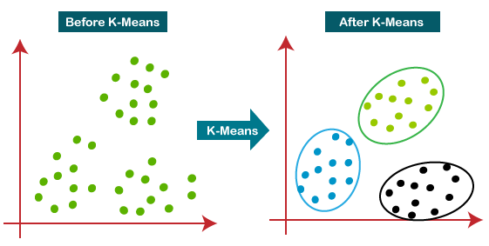

How does the K-Means Algorithm Work?
The working of the K-Means algorithm is explained in the below steps:
Step-1: Select the number K to decide the number of clusters.
Step-2: Select random K points or centroids. (It can be other from the input dataset).
Step-3: Assign each data point to their closest centroid, which will form the predefined K clusters.
Step-4: Calculate the variance and place a new centroid of each cluster.
Step-5: Repeat the third steps, which means reassign each datapoint to the new closest centroid of each cluster.
Step-6: If any reassignment occurs, then go to step-4 else go to FINISH.
Step-7: The model is ready.
Let's understand the above steps by considering the visual plots:
Suppose we have two variables M1 and M2. The x-y axis scatter plot of these two variables is given below:
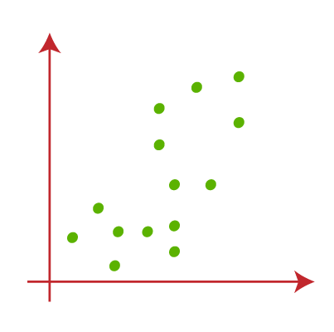
- Let's take number k of clusters, i.e., K=2, to identify the dataset and to put them into different clusters. It means here we will try to group these datasets into two different clusters.
- We need to choose some random k points or centroid to form the cluster. These points can be either the points from the dataset or any other point. So, here we are selecting the below two points as k points, which are not the part of our dataset. Consider the below image:
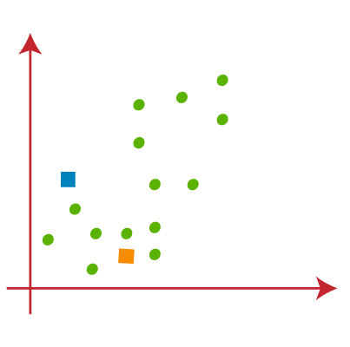
- Now we will assign each data point of the scatter plot to its closest K-point or centroid. We will compute it by applying some mathematics that we have studied to calculate the distance between two points. So, we will draw a median between both the centroids. Consider the below image:
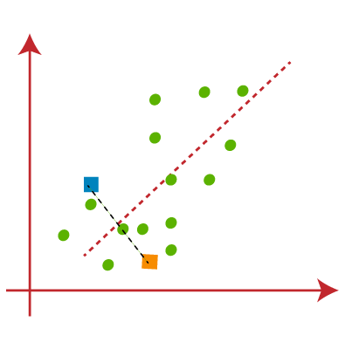
From the above image, it is clear that points left side of the line is near to the K1 or blue centroid, and points to the right of the line are close to the yellow centroid. Let's color them as blue and yellow for clear visualization.
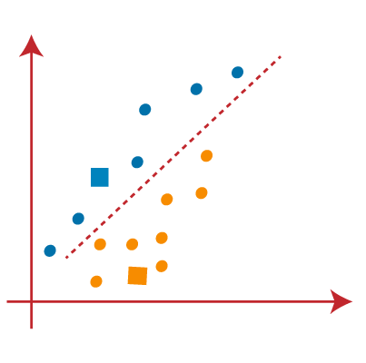
- As we need to find the closest cluster, so we will repeat the process by choosing a new centroid. To choose the new centroids, we will compute the center of gravity of these centroids, and will find new centroids as below:
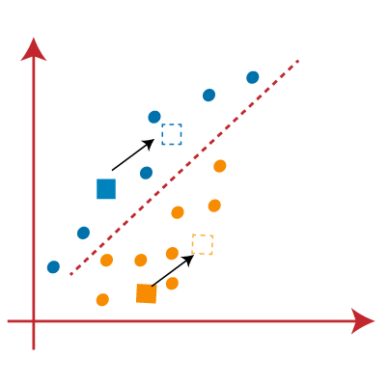
- Next, we will reassign each datapoint to the new centroid. For this, we will repeat the same process of finding a median line. The median will be like below image:
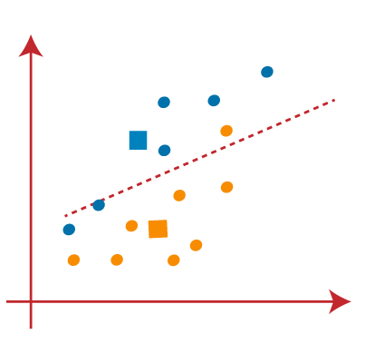
From the above image, we can see, one yellow point is on the left side of the line, and two blue points are right to the line. So, these three points will be assigned to new centroids.
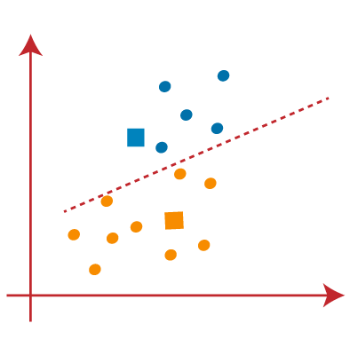
As reassignment has taken place, so we will again go to the step-4, which is finding new centroids or K-points.
- We will repeat the process by finding the center of gravity of centroids, so the new centroids will be as shown in the below image:
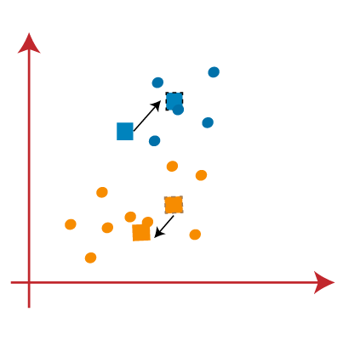
- As we got the new centroids so again will draw the median line and reassign the data points. So, the image will be:
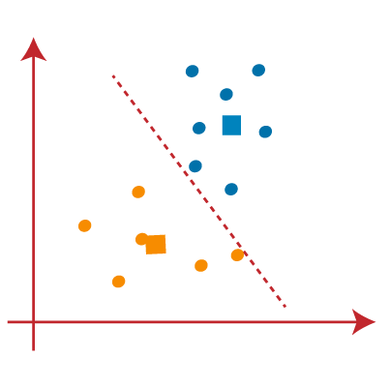
- We can see in the above image; there are no dissimilar data points on either side of the line, which means our model is formed. Consider the below image:
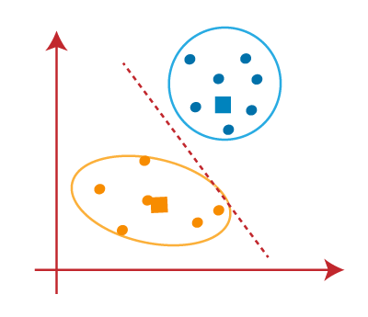
As our model is ready, so we can now remove the assumed centroids, and the two final clusters will be as shown in the below image:
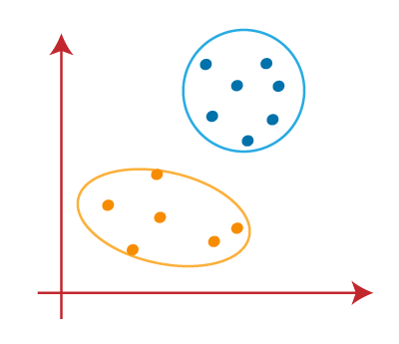

How to choose the value of "K number of clusters" in K-means Clustering?
The performance of the K-means clustering algorithm depends upon highly efficient clusters that it forms. But choosing the optimal number of clusters is a big task. There are some different ways to find the optimal number of clusters, but here we are discussing the most appropriate method to find the number of clusters or value of K. The method is given below:

Elbow Method
The Elbow method is one of the most popular ways to find the optimal number of clusters. This method uses the concept of WCSS value. WCSS stands for Within Cluster Sum of Squares, which defines the total variations within a cluster. The formula to calculate the value of WCSS (for 3 clusters) is given below:
WCSS= ∑_{Pi in Cluster1} distance(P_{i} C₁)² +∑_{Pi in Cluster2}distance(P_{i} C₂)²+∑_{Pi in CLuster3} distance(P_{i} C₃)²
In the above formula of WCSS,
∑_{Pi in Cluster1} distance(P_{i} C₁)²: It is the sum of the square of the distances between each data point and its centroid within a cluster1 and the same for the other two terms.
To measure the distance between data points and centroid, we can use any method such as Euclidean distance or Manhattan distance.
To find the optimal value of clusters, the elbow method follows the below steps:
- It executes the K-means clustering on a given dataset for different K values (ranges from 1-10).
- For each value of K, calculates the WCSS value.
- Plots a curve between calculated WCSS values and the number of clusters K.
- The sharp point of bend or a point of the plot looks like an arm, then that point is considered as the best value of K.
Since the graph shows the sharp bend, which looks like an elbow, hence it is known as the elbow method. The graph for the elbow method looks like the below image:
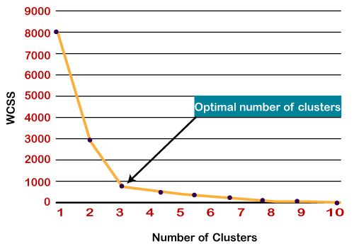

Note: We can choose the number of clusters equal to the given data points. If we choose the number of clusters equal to the data points, then the value of WCSS becomes zero, and that will be the endpoint of the plot.

Hierarchical Clustering in Machine Learning
Hierarchical clustering is another unsupervised machine learning algorithm, which is used to group the unlabeled datasets into a cluster and also known as hierarchical cluster analysis or HCA.
In this algorithm, we develop the hierarchy of clusters in the form of a tree, and this tree-shaped structure is known as the dendrogram.
Sometimes the results of K-means clustering and hierarchical clustering may look similar, but they both differ depending on how they work. As there is no requirement to predetermine the number of clusters as we did in the K-Means algorithm.
The hierarchical clustering technique has two approaches:
- Agglomerative: Agglomerative is a bottom-up approach, in which the algorithm starts with taking all data points as single clusters and merging them until one cluster is left.
- Divisive: Divisive algorithm is the reverse of the agglomerative algorithm as it is a top-down approach.

Why hierarchical clustering?
As we already have other clustering algorithms such as K-Means Clustering, then why we need hierarchical clustering? So, as we have seen in the K-means clustering that there are some challenges with this algorithm, which are a predetermined number of clusters, and it always tries to create the clusters of the same size. To solve these two challenges, we can opt for the hierarchical clustering algorithm because, in this algorithm, we don't need to have knowledge about the predefined number of clusters.
In this topic, we will discuss the Agglomerative Hierarchical clustering algorithm.

Agglomerative Hierarchical clustering
The agglomerative hierarchical clustering algorithm is a popular example of HCA. To group the datasets into clusters, it follows the bottom-up approach. It means, this algorithm considers each dataset as a single cluster at the beginning, and then start combining the closest pair of clusters together. It does this until all the clusters are merged into a single cluster that contains all the datasets.
This hierarchy of clusters is represented in the form of the dendrogram.

How the Agglomerative Hierarchical clustering Work?
The working of the AHC algorithm can be explained using the below steps:
- Step-1: Create each data point as a single cluster. Let's say there are N data points, so the number of clusters will also be N.
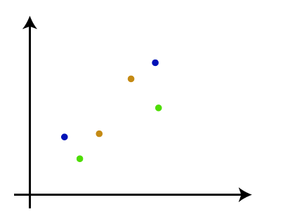
- Step-2: Take two closest data points or clusters and merge them to form one cluster. So, there will now be N-1 clusters.
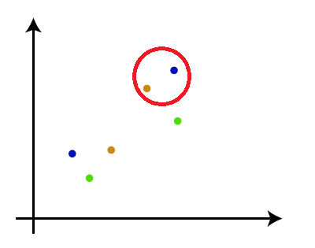
- Step-3: Again, take the two closest clusters and merge them together to form one cluster. There will be N-2 clusters.
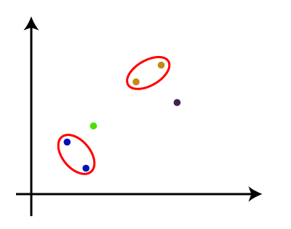
- Step-4: Repeat Step 3 until only one cluster left. So, we will get the following clusters. Consider the below images:
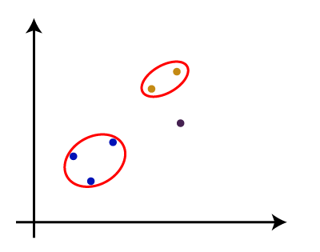
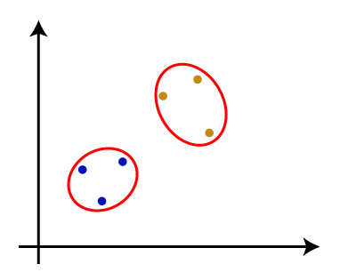
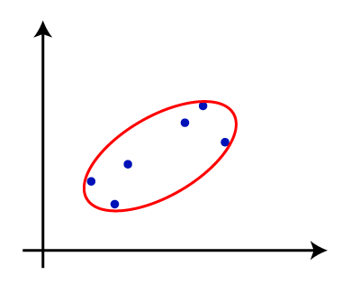
- Step-5: Once all the clusters are combined into one big cluster, develop the dendrogram to divide the clusters as per the problem.

Measure for the distance between two clusters
As we have seen, the closest distance between the two clusters is crucial for the hierarchical clustering. There are various ways to calculate the distance between two clusters, and these ways decide the rule for clustering. These measures are called Linkage methods. Some of the popular linkage methods are given below:
- Single Linkage: It is the Shortest Distance between the closest points of the clusters. Consider the below image:
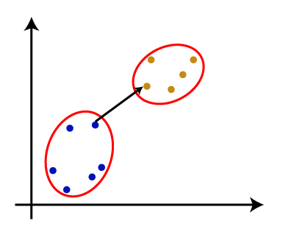
- Complete Linkage: It is the farthest distance between the two points of two different clusters. It is one of the popular linkage methods as it forms tighter clusters than single-linkage.
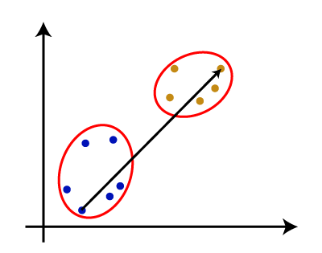
- Average Linkage: It is the linkage method in which the distance between each pair of datasets is added up and then divided by the total number of datasets to calculate the average distance between two clusters. It is also one of the most popular linkage methods.
- Centroid Linkage: It is the linkage method in which the distance between the centroid of the clusters is calculated. Consider the below image:
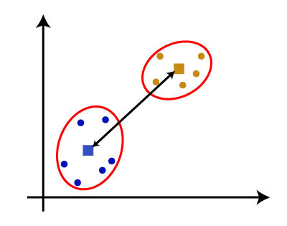
From the above-given approaches, we can apply any of them according to the type of problem or business requirement.

Woking of Dendrogram in Hierarchical clustering
The dendrogram is a tree-like structure that is mainly used to store each step as a memory that the HC algorithm performs. In the dendrogram plot, the Y-axis shows the Euclidean distances between the data points, and the x-axis shows all the data points of the given dataset.
The working of the dendrogram can be explained using the below diagram:
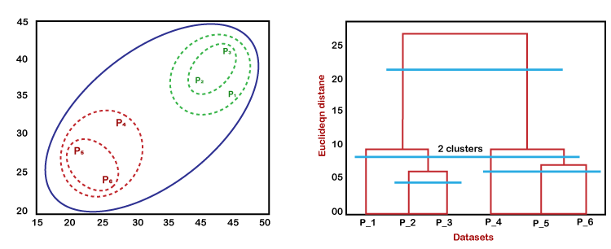
In the above diagram, the left part is showing how clusters are created in agglomerative clustering, and the right part is showing the corresponding dendrogram.
- As we have discussed above, firstly, the datapoints P2 and P3 combine together and form a cluster, correspondingly a dendrogram is created, which connects P2 and P3 with a rectangular shape. The hight is decided according to the Euclidean distance between the data points.
- In the next step, P5 and P6 form a cluster, and the corresponding dendrogram is created. It is higher than of previous, as the Euclidean distance between P5 and P6 is a little bit greater than the P2 and P3.
- Again, two new dendrograms are created that combine P1, P2, and P3 in one dendrogram, and P4, P5, and P6, in another dendrogram.
- At last, the final dendrogram is created that combines all the data points together.
We can cut the dendrogram tree structure at any level as per our requirement.

Introduction to Dimensionality Reduction Technique

What is Dimensionality Reduction?
The number of input features, variables, or columns present in a given dataset is known as dimensionality, and the process to reduce these features is called dimensionality reduction.
A dataset contains a huge number of input features in various cases, which makes the predictive modeling task more complicated. Because it is very difficult to visualize or make predictions for the training dataset with a high number of features, for such cases, dimensionality reduction techniques are required to use.
Dimensionality reduction technique can be defined as, "It is a way of converting the higher dimensions dataset into lesser dimensions dataset ensuring that it provides similar information." These techniques are widely used in machine learning for obtaining a better fit predictive model while solving the classification and regression problems.
It is commonly used in the fields that deal with high-dimensional data, such as speech recognition, signal processing, bioinformatics, etc. It can also be used for data visualization, noise reduction, cluster analysis, etc.
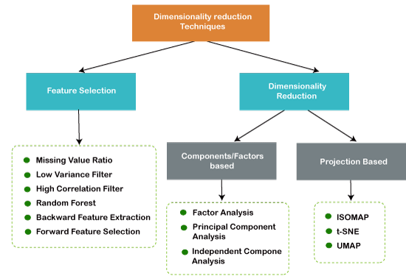

The Curse of Dimensionality
Handling the high-dimensional data is very difficult in practice, commonly known as the curse of dimensionality. If the dimensionality of the input dataset increases, any machine learning algorithm and model becomes more complex. As the number of features increases, the number of samples also gets increased proportionally, and the chance of overfitting also increases. If the machine learning model is trained on high-dimensional data, it becomes overfitted and results in poor performance.
Hence, it is often required to reduce the number of features, which can be done with dimensionality reduction.

Benefits of applying Dimensionality Reduction
Some benefits of applying dimensionality reduction technique to the given dataset are given below:
- By reducing the dimensions of the features, the space required to store the dataset also gets reduced.
- Less Computation training time is required for reduced dimensions of features.
- Reduced dimensions of features of the dataset help in visualizing the data quickly.
- It removes the redundant features (if present) by taking care of multicollinearity.

Disadvantages of dimensionality Reduction
There are also some disadvantages of applying the dimensionality reduction, which are given below:
- Some data may be lost due to dimensionality reduction.
- In the PCA dimensionality reduction technique, sometimes the principal components required to consider are unknown.

Approaches of Dimension Reduction
There are two ways to apply the dimension reduction technique, which are given below:

Feature Selection
Feature selection is the process of selecting the subset of the relevant features and leaving out the irrelevant features present in a dataset to build a model of high accuracy. In other words, it is a way of selecting the optimal features from the input dataset.
Three methods are used for the feature selection:
1. Filters Methods
In this method, the dataset is filtered, and a subset that contains only the relevant features is taken. Some common techniques of filters method are:
- Correlation
- Chi-Square Test
- ANOVA
- Information Gain, etc.
2. Wrappers Methods
The wrapper method has the same goal as the filter method, but it takes a machine learning model for its evaluation. In this method, some features are fed to the ML model, and evaluate the performance. The performance decides whether to add those features or remove to increase the accuracy of the model. This method is more accurate than the filtering method but complex to work. Some common techniques of wrapper methods are:
- Forward Selection
- Backward Selection
- Bi-directional Elimination
3. Embedded Methods: Embedded methods check the different training iterations of the machine learning model and evaluate the importance of each feature. Some common techniques of Embedded methods are:
- LASSO
- Elastic Net
- Ridge Regression, etc.

Feature Extraction:
Feature extraction is the process of transforming the space containing many dimensions into space with fewer dimensions. This approach is useful when we want to keep the whole information but use fewer resources while processing the information.
Some common feature extraction techniques are:
- Principal Component Analysis
- Linear Discriminant Analysis
- Kernel PCA
- Quadratic Discriminant Analysis

Common techniques of Dimensionality Reduction
- Principal Component Analysis
- Backward Elimination
- Forward Selection
- Score comparison
- Missing Value Ratio
- Low Variance Filter
- High Correlation Filter
- Random Forest
- Factor Analysis
- Auto-Encoder

Principal Component Analysis (PCA)
Principal Component Analysis is a statistical process that converts the observations of correlated features into a set of linearly uncorrelated features with the help of orthogonal transformation. These new transformed features are called the Principal Components. It is one of the popular tools that is used for exploratory data analysis and predictive modeling.
PCA works by considering the variance of each attribute because the high attribute shows the good split between the classes, and hence it reduces the dimensionality. Some real-world applications of PCA are image processing, movie recommendation system, optimizing the power allocation in various communication channels.

Backward Feature Elimination
The backward feature elimination technique is mainly used while developing Linear Regression or Logistic Regression model. Below steps are performed in this technique to reduce the dimensionality or in feature selection:
- In this technique, firstly, all the n variables of the given dataset are taken to train the model.
- The performance of the model is checked.
- Now we will remove one feature each time and train the model on n-1 features for n times, and will compute the performance of the model.
- We will check the variable that has made the smallest or no change in the performance of the model, and then we will drop that variable or features; after that, we will be left with n-1 features.
- Repeat the complete process until no feature can be dropped.
In this technique, by selecting the optimum performance of the model and maximum tolerable error rate, we can define the optimal number of features require for the machine learning algorithms.

Forward Feature Selection
Forward feature selection follows the inverse process of the backward elimination process. It means, in this technique, we don't eliminate the feature; instead, we will find the best features that can produce the highest increase in the performance of the model. Below steps are performed in this technique:
- We start with a single feature only, and progressively we will add each feature at a time.
- Here we will train the model on each feature separately.
- The feature with the best performance is selected.
- The process will be repeated until we get a significant increase in the performance of the model.

Missing Value Ratio
If a dataset has too many missing values, then we drop those variables as they do not carry much useful information. To perform this, we can set a threshold level, and if a variable has missing values more than that threshold, we will drop that variable. The higher the threshold value, the more efficient the reduction.

Low Variance Filter
As same as missing value ratio technique, data columns with some changes in the data have less information. Therefore, we need to calculate the variance of each variable, and all data columns with variance lower than a given threshold are dropped because low variance features will not affect the target variable.

High Correlation Filter
High Correlation refers to the case when two variables carry approximately similar information. Due to this factor, the performance of the model can be degraded. This correlation between the independent numerical variable gives the calculated value of the correlation coefficient. If this value is higher than the threshold value, we can remove one of the variables from the dataset. We can consider those variables or features that show a high correlation with the target variable.

Random Forest
Random Forest is a popular and very useful feature selection algorithm in machine learning. This algorithm contains an in-built feature importance package, so we do not need to program it separately. In this technique, we need to generate a large set of trees against the target variable, and with the help of usage statistics of each attribute, we need to find the subset of features.
Random forest algorithm takes only numerical variables, so we need to convert the input data into numeric data using hot encoding.

Factor Analysis
Factor analysis is a technique in which each variable is kept within a group according to the correlation with other variables, it means variables within a group can have a high correlation between themselves, but they have a low correlation with variables of other groups.
We can understand it by an example, such as if we have two variables Income and spend. These two variables have a high correlation, which means people with high income spends more, and vice versa. So, such variables are put into a group, and that group is known as the factor. The number of these factors will be reduced as compared to the original dimension of the dataset.

Auto-encoders
One of the popular methods of dimensionality reduction is auto-encoder, which is a type of ANN or artificial neural network, and its main aim is to copy the inputs to their outputs. In this, the input is compressed into latent-space representation, and output is occurred using this representation. It has mainly two parts:
- Encoder: The function of the encoder is to compress the input to form the latent-space representation.
- Decoder: The function of the decoder is to recreate the output from the latent-space representation.

Principal Component Analysis
Principal Component Analysis is an unsupervised learning algorithm that is used for the dimensionality reduction in machine learning
. It is a statistical process that converts the observations of correlated features into a set of linearly uncorrelated features with the help of orthogonal transformation. These new transformed features are called the Principal Components. It is one of the popular tools that is used for exploratory data analysis and predictive modeling. It is a technique to draw strong patterns from the given dataset by reducing the variances.
PCA generally tries to find the lower-dimensional surface to project the high-dimensional data.
PCA works by considering the variance of each attribute because the high attribute shows the good split between the classes, and hence it reduces the dimensionality. Some real-world applications of PCA are image processing, movie recommendation system, optimizing the power allocation in various communication channels. It is a feature extraction technique, so it contains the important variables and drops the least important variable.
The PCA algorithm is based on some mathematical concepts such as:
- Variance and Covariance
- Eigenvalues and Eigen factors
Some common terms used in PCA algorithm:
- Dimensionality: It is the number of features or variables present in the given dataset. More easily, it is the number of columns present in the dataset.
- Correlation: It signifies that how strongly two variables are related to each other. Such as if one changes, the other variable also gets changed. The correlation value ranges from -1 to +1. Here, -1 occurs if variables are inversely proportional to each other, and +1 indicates that variables are directly proportional to each other.
- Orthogonal: It defines that variables are not correlated to each other, and hence the correlation between the pair of variables is zero.
- Eigenvectors: If there is a square matrix M, and a non-zero vector v is given. Then v will be eigenvector if Av is the scalar multiple of v.
- Covariance Matrix: A matrix containing the covariance between the pair of variables is called the Covariance Matrix.

Principal Components in PCA
As described above, the transformed new features or the output of PCA are the Principal Components. The number of these PCs are either equal to or less than the original features present in the dataset. Some properties of these principal components are given below:
- The principal component must be the linear combination of the original features.
- These components are orthogonal, i.e., the correlation between a pair of variables is zero.
- The importance of each component decreases when going to 1 to n, it means the 1 PC has the most importance, and n PC will have the least importance.

Steps for PCA algorithm
- Getting the dataset
Firstly, we need to take the input dataset and divide it into two subparts X and Y, where X is the training set, and Y is the validation set.
- Representing data into a structure
Now we will represent our dataset into a structure. Such as we will represent the two-dimensional matrix of independent variable X. Here each row corresponds to the data items, and the column corresponds to the Features. The number of columns is the dimensions of the dataset.
- Standardizing the data
In this step, we will standardize our dataset. Such as in a particular column, the features with high variance are more important compared to the features with lower variance.
If the importance of features is independent of the variance of the feature, then we will divide each data item in a column with the standard deviation of the column. Here we will name the matrix as Z.
- Calculating the Covariance of Z
To calculate the covariance of Z, we will take the matrix Z, and will transpose it. After transpose, we will multiply it by Z. The output matrix will be the Covariance matrix of Z.
- Calculating the Eigen Values and Eigen Vectors
Now we need to calculate the eigenvalues and eigenvectors for the resultant covariance matrix Z. Eigenvectors or the covariance matrix are the directions of the axes with high information. And the coefficients of these eigenvectors are defined as the eigenvalues.
- Sorting the Eigen Vectors
In this step, we will take all the eigenvalues and will sort them in decreasing order, which means from largest to smallest. And simultaneously sort the eigenvectors accordingly in matrix P of eigenvalues. The resultant matrix will be named as P*.
- Calculating the new features Or Principal Components
Here we will calculate the new features. To do this, we will multiply the P* matrix to the Z. In the resultant matrix Z*, each observation is the linear combination of original features. Each column of the Z* matrix is independent of each other.
- Remove less or unimportant features from the new dataset.
The new feature set has occurred, so we will decide here what to keep and what to remove. It means, we will only keep the relevant or important features in the new dataset, and unimportant features will be removed out.

Applications of Principal Component Analysis
- PCA is mainly used as the dimensionality reduction technique in various AI applications such as computer vision, image compression, etc.
- It can also be used for finding hidden patterns if data has high dimensions. Some fields where PCA is used are Finance, data mining, Psychology, etc.

